

Milling Capacity User Manual – General User



**Prepared for**

**DIRECTORATE GENERAL OF FOOD**

**16, ABDUL GANI ROAD, DHAKA-1000.**

Submitted By

AccenTech Limited

Contents

1. Introduction 3

2. Business and Features of Milling Capacity Software 3

3. মিলের আবেদন 3

3.1 সেমি- অটোমেটিক 4

3.2 অটোমেটিক 5

3.3 রাবার শোলার বিহীন (হাস্কিং) 7

3.4 রাবার শোলার যুক্ত (মেজর) 9

4. Login by General User (UCF) 11

5. Add new miller 12

6. চালকল ম্যানেজ 12

6.1 এডিট ও ডিলিট চালকল 13

6.1.1 লাইসেন্স নবায়ন, ডুপ্লিকেট ও নতুন লাইসেন্স 13

6.1.2 লাইসেন্স প্রিন্ট 14

6.1.3 লাইসেন্স হিস্ট্রি 15

6.1.4 চালকল ফর্ম প্রিন্ট 16

6.2 চালকল পরিদর্শন 17

6.3 পাসকোড অনুসন্ধান 19

6.3.1 জেনারেট পাসকোড 19

6.4 নতুন চালকল 19

6.5 অনবায়নকৃত চালকল 20

6.6 নবায়নকৃত চালকল 20

6.7 ডুপ্লিকেট লাইসেন্স 20

6.8 একটিভিটি লগ 21

7. প্রতিবেদন 21

7.1 Drill Down to report by clicking the numbers 22

7.2 তথ্য অনুযায়ী (report from the left side) 22

7.3 অঞ্চল অনুযায়ী(report from the left side) 23

7.4 চালকলের ধরণ অনুযায়ী (report from the left side) 24

7.5 সংক্ষিপ্ত প্রতিবেদন (report from the left side) 24

8. Conclusion 25

# Introduction

This is a brief documentation of how general user operates milling capacity software.

# Business and Features of Milling Capacity Software

Determination of milling capacity software operations distributed to different role based users. These roles are: DGF, RCF, DCF, UCF, CSD, LSD. Users of these roles use login credential to get entry into the system. The users of these roles are application users.

Apart from these roles, there is an Admin role and the Admin user has responsibility to create different role, users and assign roles to users. Admin users configures all basic data like division, district, upazila, office type, office, different settings for running usual operations of the application. Admin user uses his login credential to enter into the system.

There is another type of user who does not need to login into the system, they are considered ‘Non-Login’ user. They can perform certain feature of the system.

This document describes how the application users and non-login users perform different features.

# মিলের আবেদন

Non Login user who are basically considered ‘Mill Owner’ will apply for their miller by clicking menu ‘মিলের আবেদন’ and select their desired miller type. There are 4 miller types which are described in sub section.

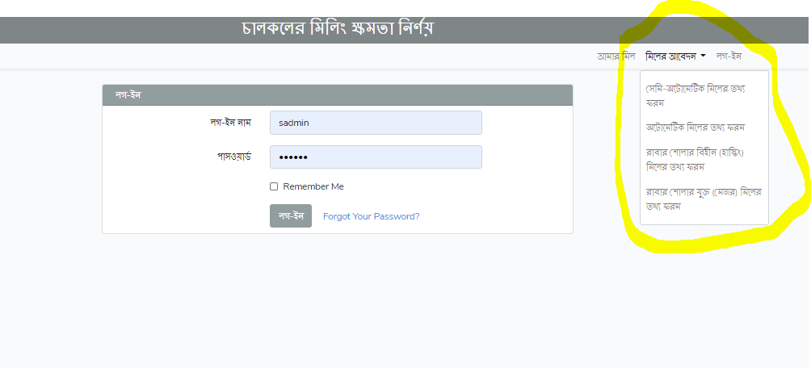

## সেমি- অটোমেটিক

This is first miller form. Users need to fill required fields that marked as required.

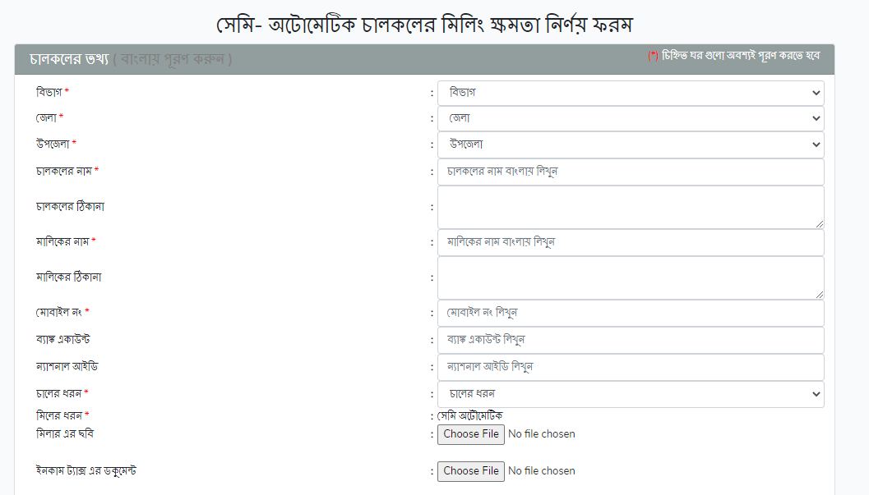

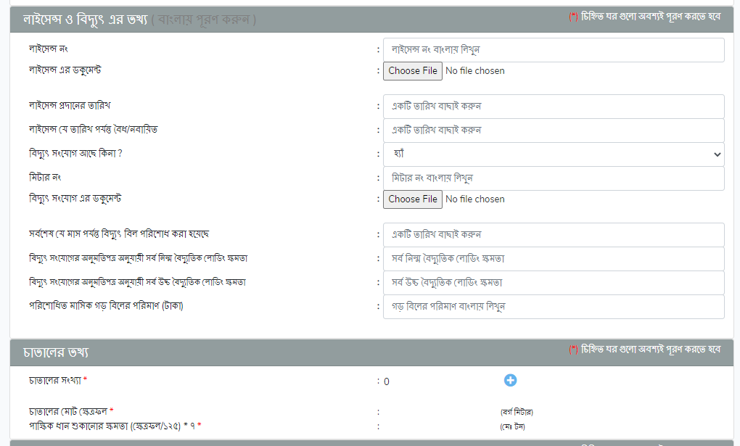

For sections “চাতালের তথ্য”, “মিলের গুদামের তথ্য”, “মটরের তথ্য”, “রাবার শোলার ও রাবার পলিশারের তথ্য” user need to click ‘+’ symbol to add information.

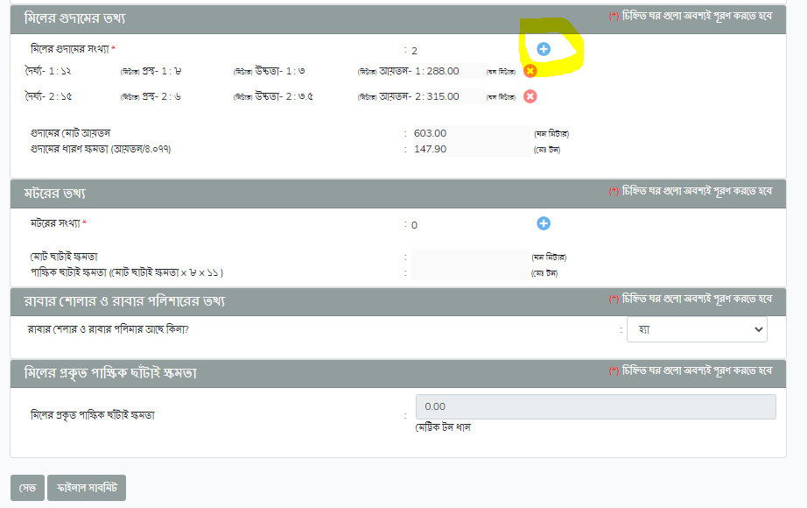

## অটোমেটিক

Automatic miller information is shown in the following image. Form fields and information are different here than other 3 miller form.

|  |
| --- |
|  |

|  |
| --- |
|  |

|  |
| --- |
|  |

|  |
| --- |
|  |

## রাবার শোলার বিহীন (হাস্কিং)

|  |
| --- |
|  |

|  |
| --- |
|  |

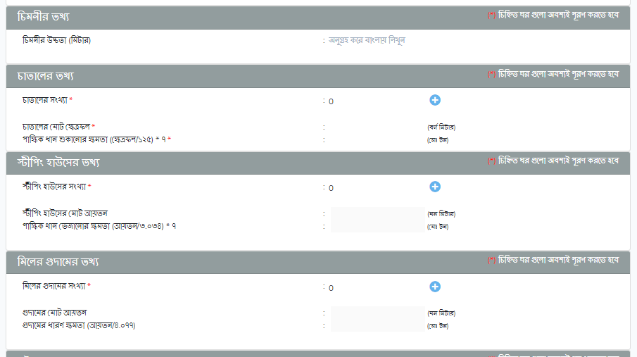

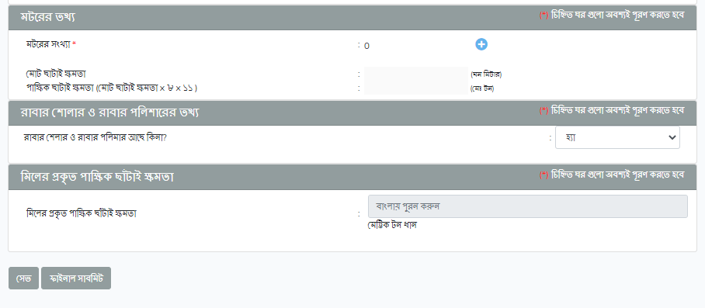

## রাবার শোলার যুক্ত (মেজর)

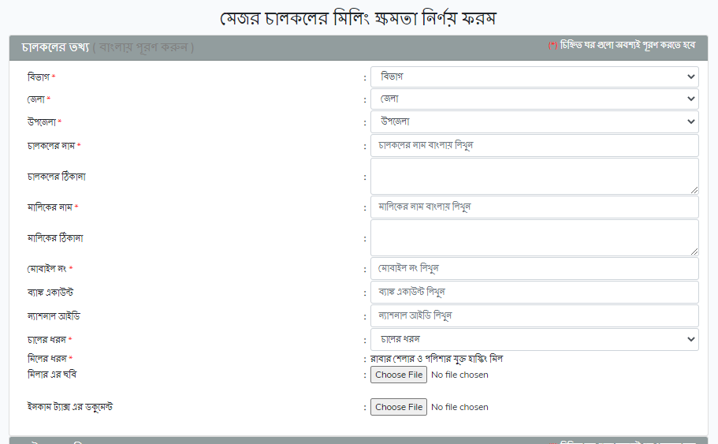

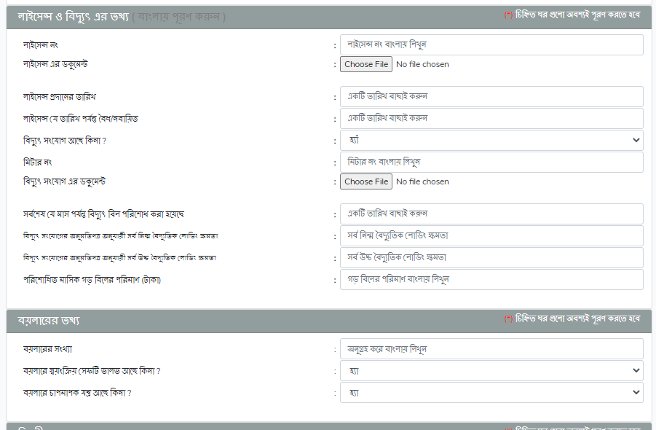

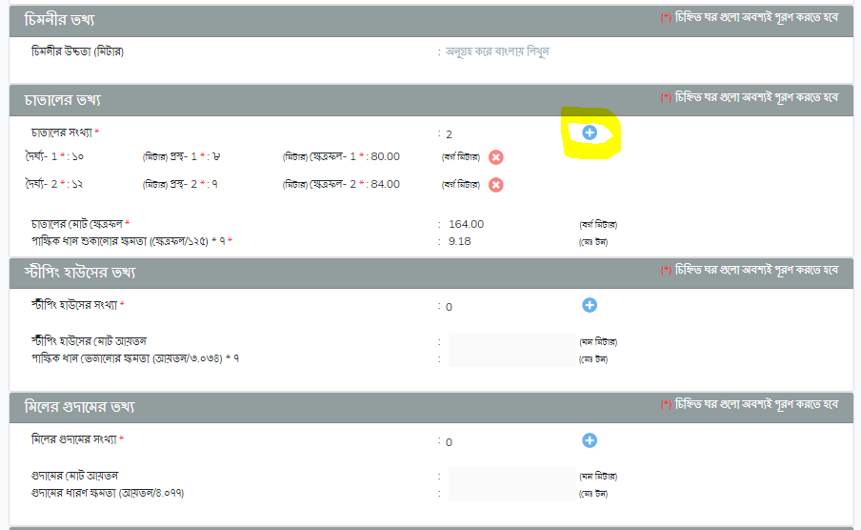

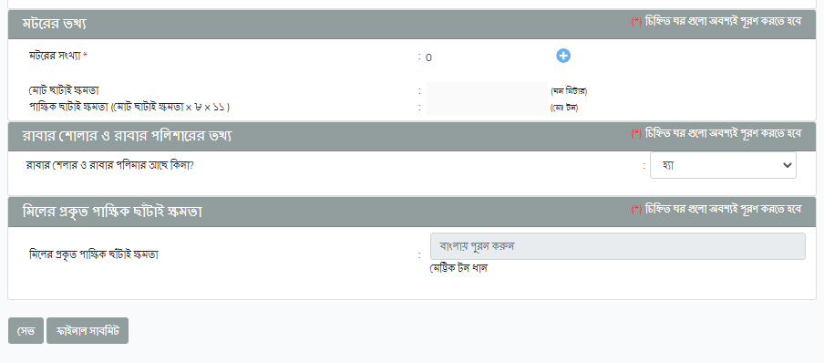

# Login by General User (UCF)

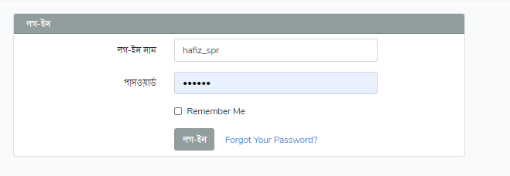

After login user will get miller summary page and menu items in navigation bar for which they have permission. 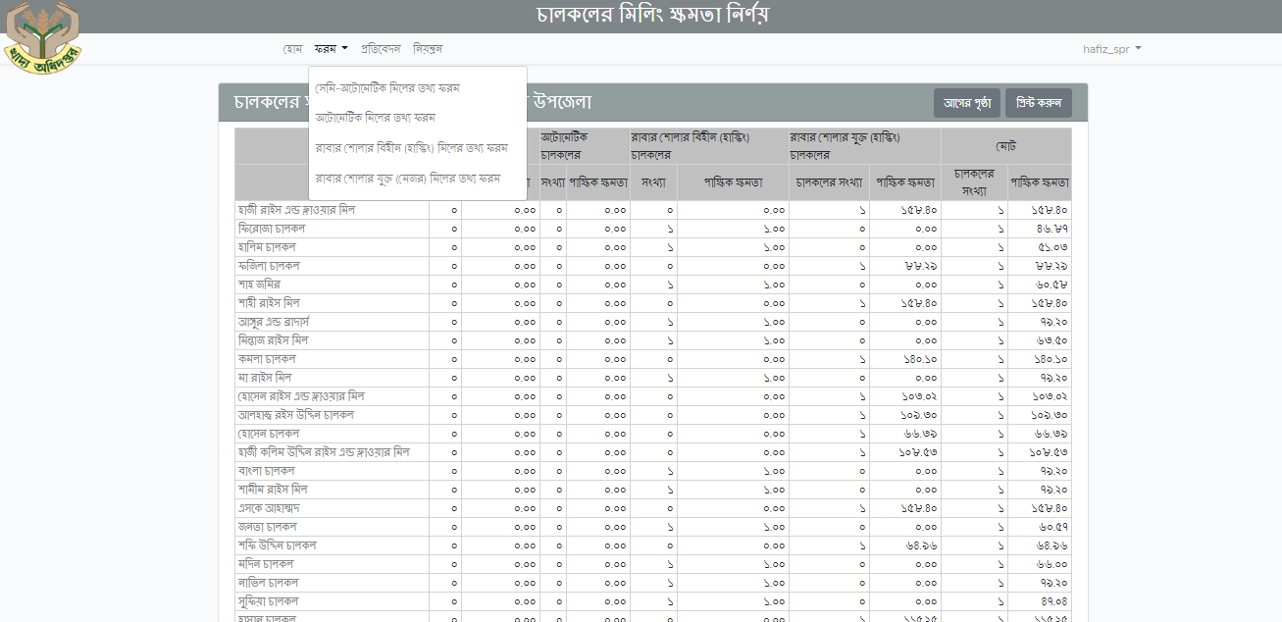

# Add new miller

To add a new miller they need to click on menu item ‘ফরম’. There are 4 forms for different type of miller. And forms are similar as shown previous section for non-login in users.

# চালকল ম্যানেজ

Click on the menu নিয়ন্ত্রণ. Lists of submenus are shown under **চালকল ম্যানেজ**. In this menu edit, delete inspection chalkol and also check passcode, license, and activity log.

|  |
| --- |
|  |

## এডিট ও ডিলিট চালকল

In this page user can filter miller list, print selected miller details, edit and delete individual miller etc. Only the user’s assigned division, district and upazila is appeared/ selected in the drop down. **User needs to go to ‘**নিয়ন্ত্রন’ -> ‘এডিট ও ডিলিট চালকল’ **page.**

|  |
| --- |
|  |

By clicking on এডিট button, user will go to the respective form like and can edit information.

### লাইসেন্স নবায়ন, ডুপ্লিকেট ও নতুন লাইসেন্স

In এডিট ও ডিলিট চালকল list, there is an option to renew/new/duplicate license. User needs to go to ‘নিয়ন্ত্রন’ -> ‘এডিট ও ডিলিট চালকল’ page. In this page user can filter miller list by division, district, and upazila depending on user’s permission.

|  |
| --- |
|  |

By clicking on button user gets license renew/new/ duplicate license issue form. See the following image. Fill with necessary data for license.

|  |
| --- |
|  |

### লাইসেন্স প্রিন্ট

In এডিট ও ডিলিট চালকল list, there is an option to print specific license. It is at the top right corner of the list. Button name is প্রিন্ট লাইসেন্স. See the following image.

|  |
| --- |
|  |

At first, select checkbox then by clicking "প্রিন্ট লাইসেন্স" user can print Chalkol License form. Following license form can be printed.

|  |
| --- |
|  |

### লাইসেন্স হিস্ট্রি

License history is available in two places:

* In the miller form and
* In the license new/renew/duplicate form.

Go to এডিট ও ডিলিট চালকল-> click on নবা/ডুপ্লি/নতুন button -> click on License renew/duplicate form-> select লাইসেন্স হিস্ট্রি button. See the following image.

|  |
| --- |
|  |

Following history view will be displayed.

|  |
| --- |
|  |

### চালকল ফর্ম প্রিন্ট

In এডিট ও ডিলিট চালকল list, there is an option to print specific license. User needs to go to ‘নিয়ন্ত্রন’ -> ‘এডিট ও ডিলিট চালকল’ page. In this page user can filter miller list by division, district, and upazila depending on user’s permission. At the top right corner of list, there is প্রিন্ট ফর্ম button

|  |
| --- |
|  |

By clicking on checkboxes from user-list, one can print one or more forms at a time.

## চালকল পরিদর্শন

Upzaila users or UCF users usually perform inspection of miller. Miller inspections are done

* at the time of new registration of miller and
* in periodically.

After inspection, DGF users either approve inspection or order to re- inspection. Based on assigned permission user can do this operation. User needs to go to ‘নিয়ন্ত্রন’ -> ‘চালকল পরিদর্শন’ page.

|  |
| --- |
|  |

In this page user can filter inspection list by period and can create new entry for inspection by selecting an individual miller for inspection.

‘Inspection Form’ for a miller as below figure where user can mark if a miller inform right or wrong and can enter their comment at the right side of each item. Finally they can mark that miller as qualified or disqualified which will need to approve by upper user.

|  |
| --- |
|  |

In the highlighted part, user can write comment if necessary.

|  |
| --- |
|  |

User can upload handwritten inspection image by clicking on Choose File.

## পাসকোড অনুসন্ধান

In this page user can search passcode by his/her phone number. User needs to go to ‘নিয়ন্ত্রন’ -> ‘পাসকোড অনুসন্ধান’ page.

Write the mobile number, and then press on ফলাফল button, then user will get his passcode.

|  |
| --- |
|  |

### জেনারেট পাসকোড

In the পাসকোড অনুসন্ধান page, admin user can generate passcode for all the millers who don’t have passcodes. It is the top right button in পাসকোড অনুসন্ধান page. See the above image.

|  |
| --- |
|  |

## নতুন চালকল

In this page user can নতুন চালকল list and also see filtering by division, district, and upazila. User needs to go to ‘নিয়ন্ত্রন’ -> ‘নতুন চালকল’ page.

|  |
| --- |
|  |

## অনবায়নকৃত চালকল

In this page user can see সচল অনবায়নকৃত লাইসেন্স list based on login user’s division, district and upazila. It shows the list of mills which licenses are not renewed by last June 30. Admin user and only admin user can inactive those rice-mills by clicking ‘Submit’ button. মিল স্টেটাস column will show correct status. User needs to go to ‘নিয়ন্ত্রন’ -> ‘অনবায়নকৃত লাইসেন্স’ page.

|  |
| --- |
|  |

## নবায়নকৃত চালকল

In this page user can see সচল নবায়নকৃত লাইসেন্স list based on login user’s division, district and upazila. User needs to go to ‘**নিয়ন্ত্রন’** -> ‘**নবায়নকৃত লাইসেন্স’** page.

|  |
| --- |
|  |

## ডুপ্লিকেট লাইসেন্স

In this page user can see ডুপ্লিকেট লাইসেন্স list and also see filtering by division, district, and upazila. User needs to go to ‘**নিয়ন্ত্রন’ -> ‘ডুপ্লিকেট লাইসেন্স’** page.

|  |
| --- |
|  |

## একটিভিটি লগ

In this page user can একটিভিটি লগ list by date range. User needs to go to ‘নিয়ন্ত্রন’ -> ‘একটিভিটি লগ’ page.

|  |
| --- |
|  |

# প্রতিবেদন

This menu shows report of rice mills. This shows numbers of chalkols based on user’s division, district and upazila. For admin user’s, it shows data of whole Bangladesh but for upazila user’s, it shows that upazila- specific data.

Apart from these there are four reports. These are shown as 4 sub menu items which are shown in left panel. See the following image.

|  |
| --- |
|  |

## Drill Down to report by clicking the numbers

User can see the report by clicking on the numbers. These are:

* পূর্ন তথ্যসম্ব্যলীত চালকলের সংখ্যা
* অসম্পূর্ন তথ্যসম্ব্যলীত চালকলের সংখ্যা
* অটোমেটিক চালকলের সংখ্যা
* সেমি অটৌমেটিক চালকলের সংখ্যা
* রাবার শেলার ও পলিশার যুক্ত হাস্কিং চালকলের সংখ্যা
* রাবার শেলার ও পলিশার বিহীন হাস্কিং চালকলের সংখ্যা

A sample report of রাবার শেলার ও পলিশার বিহীন হাস্কিং চালকলের সংখ্যা report is shown in following image. When user clicks on its number (here it is 475), following report is open. See the মিলার ধরণ column. It shows রাবার শেলার ও পলিশার বিহীন হাস্কিং চালকল list.

|  |
| --- |
|  |

## তথ্য অনুযায়ী (report from the left side)

It is a report of chalkols those are situated in different district and upazila based on তথ্য স্টেটাস. This তথ্য স্টেটাস are:

* সম্পূর্ণ
* অসম্পূর্ণ

|  |
| --- |
|  |

## অঞ্চল অনুযায়ী(report from the left side)

It is a report of chalkols those are situated in different district and upazila.

|  |
| --- |
|  |

## চালকলের ধরণ অনুযায়ী (report from the left side)

It is a report of chalkols based on mill type.

|  |
| --- |
|  |

## সংক্ষিপ্ত প্রতিবেদন (report from the left side)

This report shows division wise mill capacity based mill list. By clicking on division, user can see the district wise list and clicking on district, user can see the upazila based mill list.

|  |
| --- |
|  |

List of divisions with their milling capacity

|  |
| --- |
|  |

List of districts of Mymensingh with their milling capacity.

|  |
| --- |
|  |

List of upazilas of Sherpur district with their milling capacity

|  |
| --- |
|  |

List of Chalkols of Sherpur upazila with each of the mill’s milling capacity.

# 8. Conclusion

This document is strictly private, confidential and personal to its recipients and should not be copied, distributed or reproduced in whole or in part, nor passed to any third party.